Assignment 10: Recursive Sort and Search Algorithms using Arrays
In this assignment you will implement recursive sorting and searching algorithms. You will implement a recursive version of the quick sort and binary search algorithms.
Use the starter code for this assignment that has been uploaded into this week’s folder. The code is menu driven to make testing more interactive.
The problem you are addressing is providing information for a game rating web site. The games are individually made and not from a major gaming company (also known as Indie Games). You will read the game and a rating from a file. The file is unsorted.
You will provide a menu that provides several options for operating on the list.
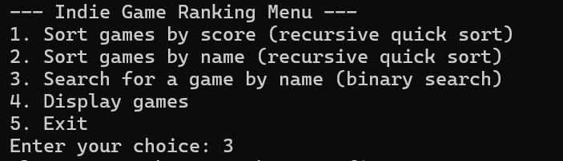
- Sort games by score. You may use a recursive quick sort or recursive bubble sort for this function.
- Sort games by name. You are to use the recursive quick sort algorithm for this sort.
- Search for a game by name. You must have an indicator of whether the list is sorted by name. The Binary Search Algorithm required the list to be sorted on the item being searched.
- Display games. Performs a non-recursive traversal of the list to display the items in it.
Example:
Trying to search an unsorted list
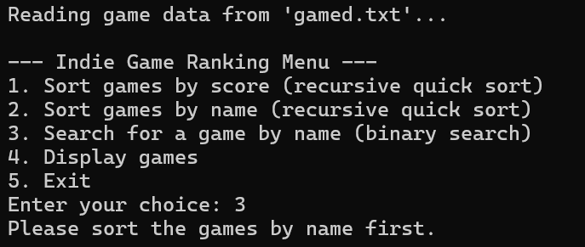
Displaying the list
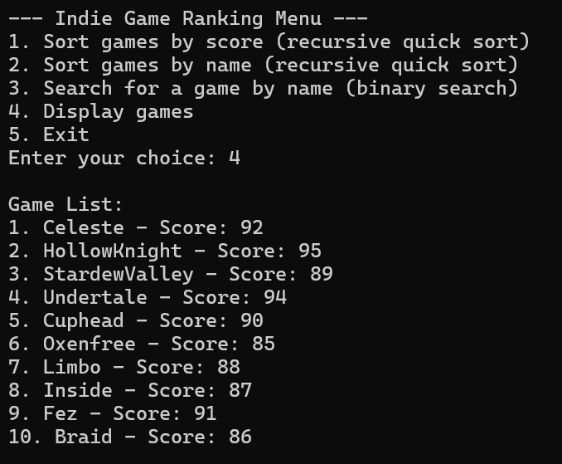

Sort the list
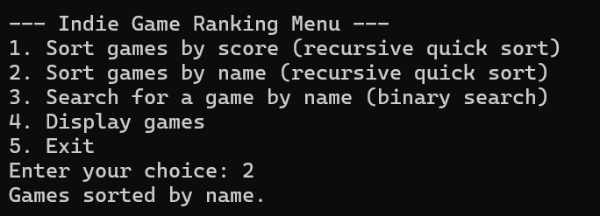

Search the list
